# Execute Java Action

To check the status

|  |
| --- |
| [root@mac127 ~]# oozie admin -oozie http://localhost:11000/oozie -status  System mode: NORMAL  [root@mac127 ~]#  [root@mac127 ~]# oozie admin -oozie http://mac127:11000/oozie -status  System mode: NORMAL  [root@mac127 ~]# |

Oozie examples are bundled within the Oozie distribution in the oozie-examples.tar.gz file.

You can find oozie-examples jars either in /usr or /opt directory if you are using Cloudera distribution

|  |
| --- |
| [root@mac127 ~]# find /usr -name "oozie*examples*"  [root@mac127 ~]# find /opt -name "oozie*examples*"  /opt/cloudera/parcels/CDH-5.9.0-1.cdh5.9.0.p0.23/lib/hue/apps/oozie/examples/workflows/spark-scala/lib/oozie-examples.jar  /opt/cloudera/parcels/CDH-5.9.0-1.cdh5.9.0.p0.23/share/doc/oozie-4.1.0+cdh5.9.0+349/oozie-examples.tar.gz  /opt/cloudera/parcels/CDH-5.9.0-1.cdh5.9.0.p0.23/jars/oozie-examples.jar  [root@mac127 ~]# |

Copy tar file in a directory

|  |
| --- |
| [root@mac127 ~]# pwd  /root  [root@mac127 ~]# mkdir oozie-demo  [root@mac127 ~]# cd oozie-demo/  [root@mac127 oozie-demo]# cp /opt/cloudera/parcels/CDH-5.9.0-1.cdh5.9.0.p0.23/share/doc/oozie-4.1.0+cdh5.9.0+349/oozie-examples.tar.gz .  [root@mac127 oozie-demo]# |

Untar file

|  |
| --- |
| [root@mac127 oozie-demo]# tar xvzf oozie-examples.tar.gz  examples/src/  examples/src/org/  examples/src/org/apache/  examples/src/org/apache/oozie/  examples/src/org/apache/oozie/example/  examples/src/org/apache/oozie/example/DateList.java  examples/src/org/apache/oozie/example/DemoJavaMain.java  examples/src/org/apache/oozie/example/DemoMapReduceMain.java  examples/src/org/apache/oozie/example/DemoMapper.java  examples/src/org/apache/oozie/example/DemoPigMain.java  examples/src/org/apache/oozie/example/DemoReducer.java  examples/src/org/apache/oozie/example/LocalOozieExample.java  examples/src/org/apache/oozie/example/Repeatable.java  examples/src/org/apache/oozie/example/SampleMapper.java  examples/src/org/apache/oozie/example/SampleOozieActionConfigurator.java  examples/src/org/apache/oozie/example/SampleReducer.java  examples/src/org/apache/oozie/example/SparkFileCopy.java  examples/src/org/apache/oozie/example/TimeUnit.java  examples/apps/  examples/apps/aggregator/  examples/apps/bundle/  examples/apps/cron-schedule/  examples/apps/cron/  examples/apps/custom-main/  examples/apps/datelist-java-main/  examples/apps/demo/  examples/apps/distcp/  examples/apps/hadoop-el/  examples/apps/hcatalog/  examples/apps/hive/  examples/apps/hive2/  examples/apps/java-main/  examples/apps/map-reduce/  examples/apps/no-op/  examples/apps/pig/  examples/apps/shell/  examples/apps/sla/  examples/apps/spark/  examples/apps/sqoop-freeform/  examples/apps/sqoop/  examples/apps/ssh/  examples/apps/streaming/  examples/apps/subwf/  examples/apps/aggregator/coordinator-with-offset.xml  examples/apps/aggregator/coordinator.xml  examples/apps/aggregator/job-with-offset.properties  examples/apps/aggregator/job.properties  examples/apps/aggregator/workflow.xml  examples/apps/bundle/bundle.xml  examples/apps/bundle/job.properties  examples/apps/cron-schedule/coordinator.xml  examples/apps/cron-schedule/job.properties  examples/apps/cron-schedule/workflow.xml  examples/apps/cron/coordinator.xml  examples/apps/cron/job.properties  examples/apps/cron/workflow.xml  examples/apps/custom-main/id.pig  examples/apps/custom-main/job.properties  examples/apps/custom-main/workflow.xml  examples/apps/datelist-java-main/job.properties  examples/apps/datelist-java-main/workflow.xml  examples/apps/demo/id.pig  examples/apps/demo/job.properties  examples/apps/demo/job.windows.properties  examples/apps/demo/workflow.xml  examples/apps/distcp/job.properties  examples/apps/distcp/workflow.xml  examples/apps/hadoop-el/job.properties  examples/apps/hadoop-el/workflow.xml  examples/apps/hcatalog/README  examples/apps/hcatalog/coordinator.xml  examples/apps/hcatalog/id.pig  examples/apps/hcatalog/job.properties  examples/apps/hcatalog/job.properties.security  examples/apps/hcatalog/workflow.xml  examples/apps/hcatalog/workflow.xml.security  examples/apps/hive/README  examples/apps/hive/job.properties  examples/apps/hive/script.q  examples/apps/hive/workflow.xml  examples/apps/hive/workflow.xml.security  examples/apps/hive2/README  examples/apps/hive2/job.properties  examples/apps/hive2/job.properties.security  examples/apps/hive2/script.q  examples/apps/hive2/workflow.xml  examples/apps/hive2/workflow.xml.security  examples/apps/java-main/job.properties  examples/apps/java-main/workflow.xml  examples/apps/map-reduce/job-with-config-class.properties  examples/apps/map-reduce/job.properties  examples/apps/map-reduce/workflow-with-config-class.xml  examples/apps/map-reduce/workflow.xml  examples/apps/no-op/job.properties  examples/apps/no-op/workflow.xml  examples/apps/pig/id.pig  examples/apps/pig/job.properties  examples/apps/pig/workflow.xml  examples/apps/shell/job.properties  examples/apps/shell/workflow.xml  examples/apps/sla/coordinator.xml  examples/apps/sla/job.properties  examples/apps/sla/workflow.xml  examples/apps/spark/job.properties  examples/apps/spark/workflow.xml  examples/apps/sqoop-freeform/db.hsqldb.properties  examples/apps/sqoop-freeform/db.hsqldb.script  examples/apps/sqoop-freeform/job.properties  examples/apps/sqoop-freeform/workflow.xml  examples/apps/sqoop/db.hsqldb.properties  examples/apps/sqoop/db.hsqldb.script  examples/apps/sqoop/job.properties  examples/apps/sqoop/workflow.xml  examples/apps/ssh/job.properties  examples/apps/ssh/workflow.xml  examples/apps/streaming/job.properties  examples/apps/streaming/job.windows.properties  examples/apps/streaming/workflow.xml  examples/apps/subwf/job.properties  examples/apps/subwf/workflow.xml  examples/input-data/text/data.txt  examples/input-data/rawLogs/2010/01/01/00/20/log01.txt  examples/input-data/rawLogs/2010/01/01/00/20/_SUCCESS  examples/input-data/rawLogs/2010/01/01/00/40/log02.txt  examples/input-data/rawLogs/2010/01/01/00/40/_SUCCESS  examples/input-data/rawLogs/2010/01/01/01/00/log03.txt  examples/input-data/rawLogs/2010/01/01/01/00/_SUCCESS  examples/input-data/rawLogs/2010/01/01/01/20/log04.txt  examples/input-data/rawLogs/2010/01/01/01/20/_SUCCESS  examples/input-data/rawLogs/2010/01/01/01/40/log05.txt  examples/input-data/rawLogs/2010/01/01/01/40/_SUCCESS  examples/input-data/rawLogs/2010/01/01/02/00/log06.txt  examples/input-data/rawLogs/2010/01/01/02/00/_SUCCESS  examples/apps/aggregator/lib/oozie-examples-4.1.0-cdh5.9.0.jar  examples/apps/custom-main/lib/oozie-examples-4.1.0-cdh5.9.0.jar  examples/apps/demo/lib/oozie-examples-4.1.0-cdh5.9.0.jar  examples/apps/hadoop-el/lib/oozie-examples-4.1.0-cdh5.9.0.jar  examples/apps/java-main/lib/oozie-examples-4.1.0-cdh5.9.0.jar  examples/apps/datelist-java-main/lib/oozie-examples-4.1.0-cdh5.9.0.jar  examples/apps/map-reduce/lib/oozie-examples-4.1.0-cdh5.9.0.jar  examples/apps/spark/lib/oozie-examples.jar  [root@mac127 oozie-demo]# |

|  |
| --- |
| [root@mac127 oozie-demo]# ls -ltr  total 48  -rwxr-xr-x 1 root root 46265 Feb 4 00:46 oozie-examples.tar.gz  drwxr-xr-x 5 root root 44 Feb 4 00:47 examples  [root@mac127 oozie-demo]# |

Go to apps/java-main

|  |
| --- |
| [root@mac127 examples]# ls -l  total 4  drwxr-xr-x 26 1106 4001 4096 Oct 21 13:26 apps  drwxr-xr-x 4 root root 31 Feb 4 00:47 input-data  drwxr-xr-x 3 1106 4001 16 Oct 21 13:26 src  [root@mac127 input-data]# cd apps/  [root@mac127 apps]# ls -l  total 0  drwxr-xr-x 3 1106 4001 145 Feb 4 00:47 aggregator  drwxr-xr-x 2 1106 4001 44 Feb 4 00:47 bundle  drwxr-xr-x 2 1106 4001 68 Feb 4 00:47 cron  drwxr-xr-x 2 1106 4001 68 Feb 4 00:47 cron-schedule  drwxr-xr-x 3 1106 4001 69 Feb 4 00:47 custom-main  drwxr-xr-x 3 1106 4001 56 Feb 4 00:47 datelist-java-main  drwxr-xr-x 3 1106 4001 98 Feb 4 00:47 demo  drwxr-xr-x 2 1106 4001 46 Feb 4 00:47 distcp  drwxr-xr-x 3 1106 4001 56 Feb 4 00:47 hadoop-el  drwxr-xr-x 2 1106 4001 152 Feb 4 00:47 hcatalog  drwxr-xr-x 2 1106 4001 102 Feb 4 00:47 hive  drwxr-xr-x 2 1106 4001 132 Feb 4 00:47 hive2  drwxr-xr-x 3 1106 4001 56 Feb 4 00:47 java-main  drwxr-xr-x 3 1106 4001 132 Feb 4 00:47 map-reduce  drwxr-xr-x 2 1106 4001 46 Feb 4 00:47 no-op  drwxr-xr-x 2 1106 4001 59 Feb 4 00:47 pig  drwxr-xr-x 2 1106 4001 46 Feb 4 00:47 shell  drwxr-xr-x 2 1106 4001 68 Feb 4 00:47 sla  drwxr-xr-x 3 1106 4001 56 Feb 4 00:47 spark  drwxr-xr-x 2 1106 4001 96 Feb 4 00:47 sqoop  drwxr-xr-x 2 1106 4001 96 Feb 4 00:47 sqoop-freeform  drwxr-xr-x 2 1106 4001 46 Feb 4 00:47 ssh  drwxr-xr-x 2 1106 4001 75 Feb 4 00:47 streaming  drwxr-xr-x 2 1106 4001 46 Feb 4 00:47 subwf  [root@mac127 apps]# |

|  |
| --- |
| [root@mac127 apps]# cd java-main/  [root@mac127 java-main]# ls -l  total 8  -rw-r--r-- 1 1106 4001 977 Oct 21 13:26 job.properties  drwxr-xr-x 2 root root 46 Feb 4 00:47 lib  -rw-r--r-- 1 1106 4001 1631 Oct 21 13:26 workflow.xml  [root@mac127 java-main]# |

Check lib contents

|  |
| --- |
| [root@mac127 java-main]# ls -ltr lib  total 28  -rw-r--r-- 1 1106 4001 27656 Oct 21 13:49 oozie-examples-4.1.0-cdh5.9.0.jar |

Check jar files using **jar tvf** command

|  |
| --- |
| [root@mac127 java-main]# /usr/java/jdk1.7.0_67-cloudera/bin/jar tvf lib/oozie-examples-4.1.0-cdh5.9.0.jar  0 Fri Oct 21 01:19:18 IST 2016 META-INF/  126 Fri Oct 21 01:19:16 IST 2016 META-INF/MANIFEST.MF  0 Fri Oct 21 01:19:16 IST 2016 org/  0 Fri Oct 21 01:19:16 IST 2016 org/apache/  0 Fri Oct 21 01:19:16 IST 2016 org/apache/oozie/  0 Fri Oct 21 01:19:16 IST 2016 org/apache/oozie/example/  169 Fri Oct 21 01:19:16 IST 2016 META-INF/NOTICE  11358 Fri Oct 21 01:19:16 IST 2016 META-INF/LICENSE  31470 Fri Oct 21 01:19:16 IST 2016 META-INF/DEPENDENCIES  4455 Fri Oct 21 01:19:16 IST 2016 org/apache/oozie/example/LocalOozieExample.class  962 Fri Oct 21 01:19:16 IST 2016 org/apache/oozie/example/DemoJavaMain.class  2213 Fri Oct 21 01:19:16 IST 2016 org/apache/oozie/example/DemoReducer.class  4211 Fri Oct 21 01:19:16 IST 2016 org/apache/oozie/example/DateList.class  2528 Fri Oct 21 01:19:16 IST 2016 org/apache/oozie/example/DemoMapper.class  2126 Fri Oct 21 01:19:16 IST 2016 org/apache/oozie/example/SampleMapper.class  354 Fri Oct 21 01:19:16 IST 2016 org/apache/oozie/example/DemoMapReduceMain.class  1932 Fri Oct 21 01:19:16 IST 2016 org/apache/oozie/example/SampleOozieActionConfigurator.class  1298 Fri Oct 21 01:19:16 IST 2016 org/apache/oozie/example/TimeUnit.class  1684 Fri Oct 21 01:19:16 IST 2016 org/apache/oozie/example/SparkFileCopy.class  3537 Fri Oct 21 01:19:16 IST 2016 org/apache/oozie/example/Repeatable.class  330 Fri Oct 21 01:19:16 IST 2016 org/apache/oozie/example/DemoPigMain.class  2310 Fri Oct 21 01:19:16 IST 2016 org/apache/oozie/example/SampleReducer.class  0 Fri Oct 21 01:19:18 IST 2016 META-INF/maven/  0 Fri Oct 21 01:19:18 IST 2016 META-INF/maven/org.apache.oozie/  0 Fri Oct 21 01:19:18 IST 2016 META-INF/maven/org.apache.oozie/oozie-examples/  6819 Fri Oct 21 00:56:52 IST 2016 META-INF/maven/org.apache.oozie/oozie-examples/pom.xml  124 Fri Oct 21 01:19:18 IST 2016 META-INF/maven/org.apache.oozie/oozie-examples/pom.properties  [root@mac127 java-main]# |

So we are trying to invoke DemoJavaMain

|  |
| --- |
| [root@mac127 java-main]# cat workflow.xml  <!--  Licensed to the Apache Software Foundation (ASF) under one  or more contributor license agreements. See the NOTICE file  distributed with this work for additional information  regarding copyright ownership. The ASF licenses this file  to you under the Apache License, Version 2.0 (the  "License"); you may not use this file except in compliance  with the License. You may obtain a copy of the License at  http://www.apache.org/licenses/LICENSE-2.0  Unless required by applicable law or agreed to in writing, software  distributed under the License is distributed on an "AS IS" BASIS,  WITHOUT WARRANTIES OR CONDITIONS OF ANY KIND, either express or implied.  See the License for the specific language governing permissions and  limitations under the License.  -->  <workflow-app xmlns="uri:oozie:workflow:0.2" name="java-main-wf">  <start to="java-node"/> 🡨 this is the Starting Actin 🡪  <action name="java-node">  <java>  <job-tracker>${jobTracker}</job-tracker>  <name-node>${nameNode}</name-node>  <configuration>  <property>  <name>mapred.job.queue.name</name>  <value>${queueName}</value>  </property>  </configuration>  <main-class>org.apache.oozie.example.DemoJavaMain</main-class>  <arg>Hello</arg>  <arg>Oozie!</arg>  </java>  <ok to="end"/>  <error to="fail"/>  </action>  <kill name="fail">  <message>Java failed, error message[${wf:errorMessage(wf:lastErrorNode())}]</message>  </kill>  <end name="end"/>  </workflow-app> |

Workflow.xml contains the actual workflow, here we are running only one program but we can have more than one action in a single workflow

|  |
| --- |
| [root@mac127 java-main]# cat job.properties  #  # Licensed to the Apache Software Foundation (ASF) under one  # or more contributor license agreements. See the NOTICE file  # distributed with this work for additional information  # regarding copyright ownership. The ASF licenses this file  # to you under the Apache License, Version 2.0 (the  # "License"); you may not use this file except in compliance  # with the License. You may obtain a copy of the License at  #  # http://www.apache.org/licenses/LICENSE-2.0  #  # Unless required by applicable law or agreed to in writing, software  # distributed under the License is distributed on an "AS IS" BASIS,  # WITHOUT WARRANTIES OR CONDITIONS OF ANY KIND, either express or implied.  # See the License for the specific language governing permissions and  # limitations under the License.  #  nameNode=hdfs://localhost:8020  jobTracker=localhost:8021  queueName=default  examplesRoot=examples  oozie.wf.application.path=${nameNode}/user/${user.name}/${examplesRoot}/apps/java-main |

Verify correct port number for namenode and Resource manager (jobtracker) here jobTracker is just a property name if we want we can change it to resourceManager and we need to change it in workflow.xml as well

Job.properties is file which contains different properties which are required by workflow.xml file

oozie.wf.application.path=${nameNode}/user/${user.name}/${examplesRoot}/apps/java-main

Here $(user.name) is the name of the user which we used to submit the oozie job

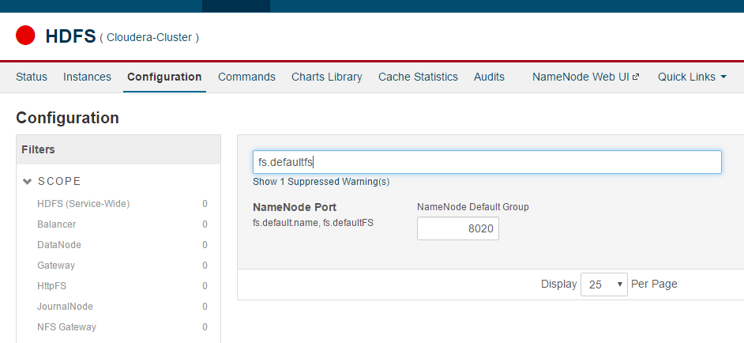

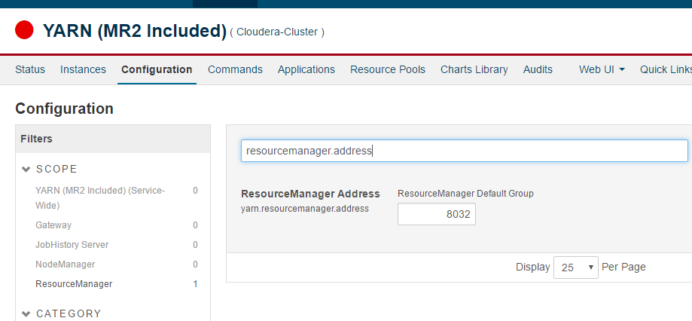

So as we can see that resource manager port is 8032 and in job.properties it is mentioned as 8021 so change it accordingly

|  |
| --- |
| nameNode=hdfs://mac127:8020  jobTracker=mac127:8032  queueName=default  examplesRoot=examples  oozie.wf.application.path=${nameNode}/user/${user.name}/${examplesRoot}/apps/java-main |

Always use hostname instead of local host you can get the hostname information by downloading client configuration from Action drop down from HDFS and Yarn both and check core-site.xml and yarn-site.xml and check the properties (**fs.defaultfs** and **yarn.resourcemanager.address**) that we searched on Cloudera manager(Cloudera manager doesn’t show the hostname information in UI)

Note: if HA is configured we need to give the nameservice name instead of IP:Port you can get this information from core-site.xml and yarn-site.xml

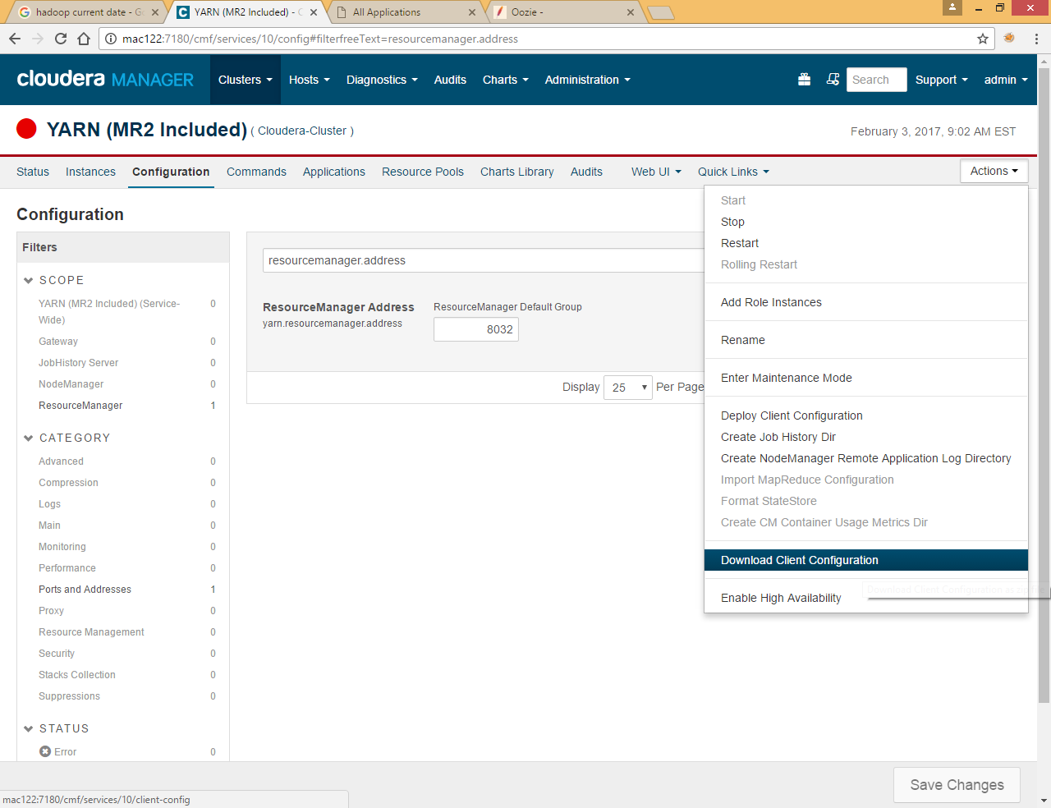

Before submitting the job we need to copy all files into **oozie.wf.application.path**=${nameNode}/user/${user.name}/${examplesRoot}/apps/java-main

Put example directory to hdfs location which mentioned in **oozie.wf.application.path**

|  |
| --- |
| [root@mac127 oozie-demo]# hdfs dfs -put examples /user/root/examples  [root@mac127 oozie-demo]# hdfs dfs -ls /user/root/examples  Found 3 items  drwxr-xr-x - root root 0 2017-02-04 01:23 /user/root/examples/apps  drwxr-xr-x - root root 0 2017-02-04 01:23 /user/root/examples/input-data  drwxr-xr-x - root root 0 2017-02-04 01:23 /user/root/examples/src  [root@mac127 oozie-demo]# hdfs dfs -ls /user/root/examples/apps/java-main  Found 3 items  -rw-r--r-- 3 root root 977 2017-02-04 01:23 /user/root/examples/apps/java-main/job.properties  drwxr-xr-x - root root 0 2017-02-04 01:23 /user/root/examples/apps/java-main/lib  -rw-r--r-- 3 root root 1631 2017-02-04 01:23 /user/root/examples/apps/java-main/workflow.xml  [root@mac127 oozie-demo]# |

Run oozie job by below command

|  |
| --- |
| [root@mac127 java-main]# oozie job -oozie http://mac127:11000/oozie -config /root/oozie-demo/examples/apps/java-main/job.properties -run  job: 0000019-170203205027370-oozie-oozi-W |

Highlighted part is file under local file system

You can get the information of job by using below command just paste the job id created by oozie job above after -info

|  |
| --- |
| [root@mac127 java-main]# oozie job -oozie http://mac127:11000/oozie -info 0000019-170203205027370-oozie-oozi-W  Job ID : 0000019-170203205027370-oozie-oozi-W  ------------------------------------------------------------------------------------------------------------------------------------  Workflow Name : java-main-wf  App Path : hdfs://mac127:8020/user/root/examples/apps/java-main  Status : SUCCEEDED  Run : 0  User : root  Group : -  Created : 2017-02-03 20:00 GMT  Started : 2017-02-03 20:00 GMT  Last Modified : 2017-02-03 20:00 GMT  Ended : 2017-02-03 20:00 GMT  CoordAction ID: -  Actions  ------------------------------------------------------------------------------------------------------------------------------------  ID Status Ext ID Ext Status Err Code  ------------------------------------------------------------------------------------------------------------------------------------  0000019-170203205027370-oozie-oozi-W@:start: OK - OK -  ------------------------------------------------------------------------------------------------------------------------------------  0000019-170203205027370-oozie-oozi-W@java-node OK job_1484320332413_0037 SUCCEEDED -  ------------------------------------------------------------------------------------------------------------------------------------  0000019-170203205027370-oozie-oozi-W@end OK - OK -  ------------------------------------------------------------------------------------------------------------------------------------ |

To check the log run below command

|  |
| --- |
| oozie job -oozie http://mac127:11000/oozie -log 0000019-170203205027370-oozie-oozi-W |

You can also check the same in Resource Manager UI <http://mac127:8088/cluster>

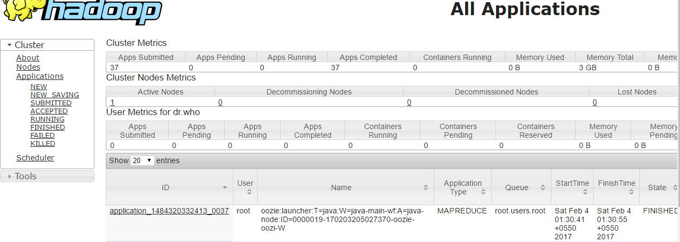

Click on link

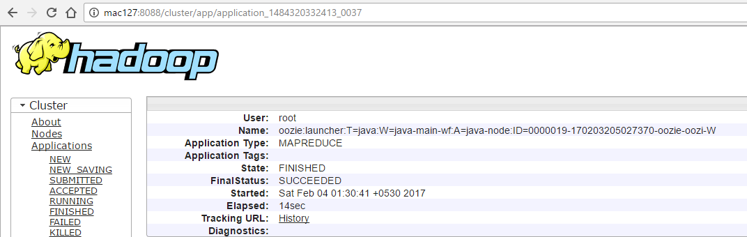

Click history

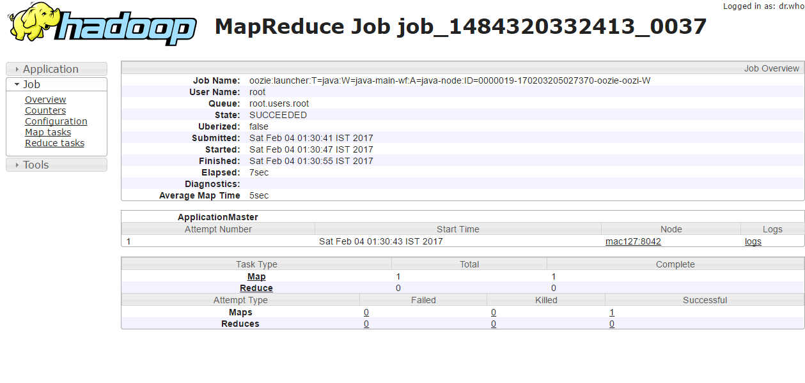

Click Map

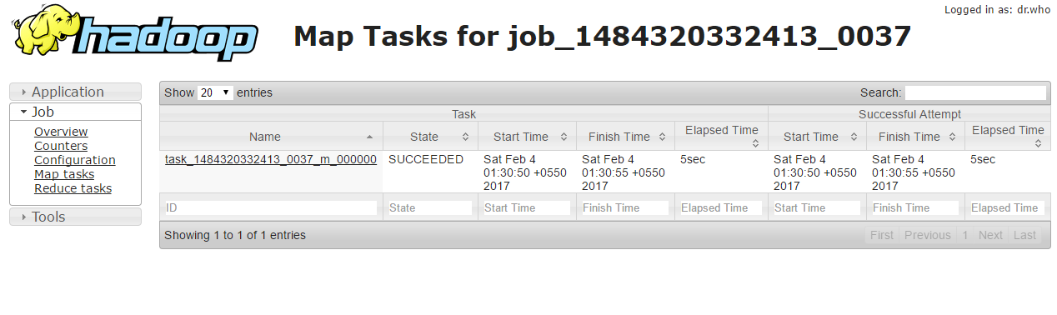

Click Task link

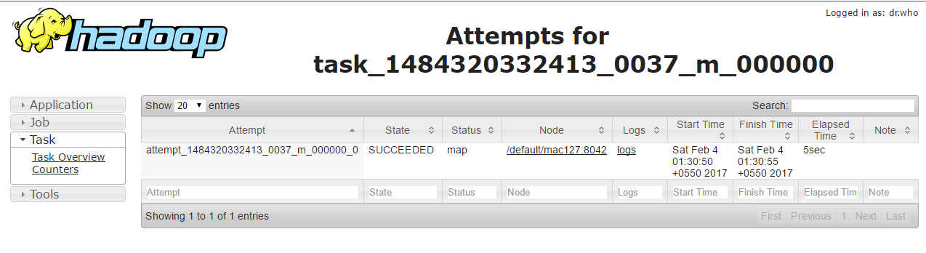

Click logs

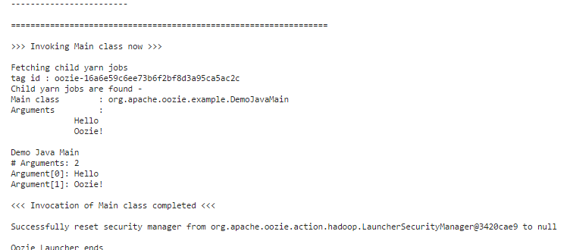

# Execute Map Reduce Action

Check mapreduce class in jar file

|  |  |
| --- | --- |
| [root@mac127 java-main]# /usr/java/jdk1.7.0_67-cloudera/bin/jar tvf lib/oozie-examples-4.1.0-cdh5.9.0.jar  0 Fri Oct 21 01:19:18 IST 2016 META-INF/  126 Fri Oct 21 01:19:16 IST 2016 META-INF/MANIFEST.MF  0 Fri Oct 21 01:19:16 IST 2016 org/  0 Fri Oct 21 01:19:16 IST 2016 org/apache/  0 Fri Oct 21 01:19:16 IST 2016 org/apache/oozie/  0 Fri Oct 21 01:19:16 IST 2016 org/apache/oozie/example/  169 Fri Oct 21 01:19:16 IST 2016 META-INF/NOTICE  11358 Fri Oct 21 01:19:16 IST 2016 META-INF/LICENSE  31470 Fri Oct 21 01:19:16 IST 2016 META-INF/DEPENDENCIES  4455 Fri Oct 21 01:19:16 IST 2016 org/apache/oozie/example/LocalOozieExample.class  962 Fri Oct 21 01:19:16 IST 2016 org/apache/oozie/example/DemoJavaMain.class  2213 Fri Oct 21 01:19:16 IST 2016 org/apache/oozie/example/DemoReducer.class  4211 Fri Oct 21 01:19:16 IST 2016 org/apache/oozie/example/DateList.class  2528 Fri Oct 21 01:19:16 IST 2016 org/apache/oozie/example/DemoMapper.class  2126 Fri Oct 21 01:19:16 IST 2016 org/apache/oozie/example/SampleMapper.class  354 Fri Oct 21 01:19:16 IST 2016 org/apache/oozie/example/DemoMapReduceMain.class  1932 Fri Oct 21 01:19:16 IST 2016 org/apache/oozie/example/SampleOozieActionConfigurator.class  1298 Fri Oct 21 01:19:16 IST 2016 org/apache/oozie/example/TimeUnit.class  1684 Fri Oct 21 01:19:16 IST 2016 org/apache/oozie/example/SparkFileCopy.class  3537 Fri Oct 21 01:19:16 IST 2016 org/apache/oozie/example/Repeatable.class  330 Fri Oct 21 01:19:16 IST 2016 org/apache/oozie/example/DemoPigMain.class  2310 Fri Oct 21 01:19:16 IST 2016 org/apache/oozie/example/SampleReducer.class  0 Fri Oct 21 01:19:18 IST 2016 META-INF/maven/  0 Fri Oct 21 01:19:18 IST 2016 META-INF/maven/org.apache.oozie/  0 Fri Oct 21 01:19:18 IST 2016 META-INF/maven/org.apache.oozie/oozie-examples/  6819 Fri Oct 21 00:56:52 IST 2016 META-INF/maven/org.apache.oozie/oozie-examples/pom.xml  124 Fri Oct 21 01:19:18 IST 2016 META-INF/maven/org.apache.oozie/oozie-examples/pom.properties  [root@mac127 java-main]# |  |

|  |
| --- |
| [root@mac127 map-reduce]# pwd  /root/oozie-demo/examples/apps/map-reduce  [root@mac127 map-reduce]# ls -l  total 16  -rw-r--r-- 1 1106 4001 1012 Oct 21 13:26 job.properties  -rw-r--r-- 1 1106 4001 1028 Oct 21 13:26 job-with-config-class.properties  drwxr-xr-x 2 root root 46 Feb 4 00:47 lib  -rw-r--r-- 1 1106 4001 2274 Oct 21 13:26 workflow-with-config-class.xml  -rw-r--r-- 1 1106 4001 2559 Oct 21 13:26 workflow.xml  [root@mac127 map-reduce]# |

Change job.properties file

|  |
| --- |
| nameNode=hdfs://mac127:8020  jobTracker=mac127:8032  queueName=default  examplesRoot=examples  oozie.wf.application.path=${nameNode}/user/${user.name}/${examplesRoot}/apps/map-reduce/workflow.xml  outputDir=map-reduce |

Workflow.xml

|  |
| --- |
| <workflow-app xmlns="uri:oozie:workflow:0.2" name="map-reduce-wf">  <start to="mr-node"/>  <action name="mr-node">  <map-reduce>  <job-tracker>${jobTracker}</job-tracker>  <name-node>${nameNode}</name-node>  <!—prepare tag is for any prerequisites it’s like setup method -- >  <prepare>  <delete path="${nameNode}/user/${wf:user()}/${examplesRoot}/output-data/${outputDir}"/>  </prepare>  <configuration>  <property>  <name>mapred.job.queue.name</name>  <value>${queueName}</value>  </property>  <property>  <name>mapred.mapper.class</name>  <value>org.apache.oozie.example.SampleMapper</value>  </property>  <property>  <name>mapred.reducer.class</name>  <value>org.apache.oozie.example.SampleReducer</value>  </property>  <property>  <name>mapred.map.tasks</name>  <value>1</value>  </property>  <property>  <name>mapred.input.dir</name>  <value>/user/${wf:user()}/${examplesRoot}/input-data/text</value>  </property>  <property>  <name>mapred.output.dir</name>  <value>/user/${wf:user()}/${examplesRoot}/output-data/${outputDir}</value>  </property>  </configuration>  </map-reduce>  <ok to="end"/>  <error to="fail"/>  </action>  <kill name="fail">  <message>Map/Reduce failed, error message[${wf:errorMessage(wf:lastErrorNode())}]</message>  </kill>  <end name="end"/>  </workflow-app> |

We already put example folder under hdfs which contains all library datasets and workflow

We can check if input data folder exists on hdfs

|  |
| --- |
| [root@mac127 map-reduce]# hdfs dfs -ls /user/root/examples/input-data/text  Found 1 items  -rw-r--r-- 3 root root 1409 2017-02-04 01:23 /user/root/examples/input-data/text/data.txt  [root@mac127 map-reduce]# |

Run oozie job

|  |
| --- |
| oozie job -oozie http://mac127:11000/oozie -config /root/oozie-demo/examples/apps/map-reduce/job.properties -run  job: 0000024-170203205027370-oozie-oozi-W |

Check RM UI

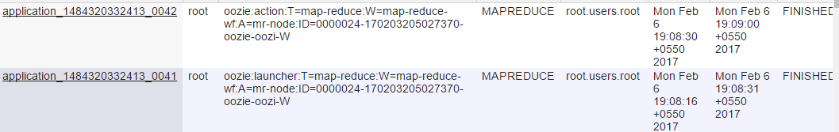

We can see two jobs, one is oozie job that launch mapreduce job and second is actual map reduce job

You can see output folder after successful execution of this job

|  |
| --- |
| [root@mac127 map-reduce]# hdfs dfs -ls /user/root/examples/output-data/map-reduce  Found 3 items  -rw-r--r-- 3 root root 0 2017-02-06 19:09 /user/root/examples/output-data/map-reduce/_SUCCESS  -rw-r--r-- 3 root root 717 2017-02-06 19:08 /user/root/examples/output-data/map-reduce/part-00000  -rw-r--r-- 3 root root 830 2017-02-06 19:08 /user/root/examples/output-data/map-reduce/part-00001  [root@mac127 map-reduce]# hdfs dfs -cat /user/root/examples/output-data/map-reduce/par*  0 To be or not to be, that is the question;  42 Whether 'tis nobler in the mind to suffer  84 The slings and arrows of outrageous fortune,  172 And by opposing, end them. To die, to sleep;  302 That flesh is heir to ? 'tis a consummation  346 Devoutly to be wish'd. To die, to sleep;  438 For in that sleep of death what dreams may come,  608 For who would bear the whips and scorns of time,  706 The pangs of despised love, the law's delay,  832 When he himself might his quietus make  954 But that the dread of something after death,  1210 And thus the native hue of resolution  1248 Is sicklied o'er with the pale cast of thought,  1296 And enterprises of great pitch and moment  1338 With this regard their currents turn awry,  129 Or to take arms against a sea of troubles,  217 No more; and by a sleep to say we end  255 The heart-ache and the thousand natural shocks  387 To sleep, perchance to dream. Ay, there's the rub,  487 When we have shuffled off this mortal coil,  531 Must give us pause. There's the respect  571 That makes calamity of so long life,  657 Th'oppressor's wrong, the proud man's contumely,  751 The insolence of office, and the spurns  791 That patient merit of th'unworthy takes,  871 With a bare bodkin? who would fardels bear,  915 To grunt and sweat under a weary life,  999 The undiscovered country from whose bourn  1041 No traveller returns, puzzles the will,  1081 And makes us rather bear those ills we have  1125 Than fly to others that we know not of?  1165 Thus conscience does make cowards of us all,  1381 And lose the name of action. |